Implementing the Singleton Pattern

//SingletonPatternExample.java
class Logger {
private static Logger instance;
private Logger() {
System.out.println("Logger instance created.");
}
public static Logger getInstance() {
if (instance == null) {
instance = new Logger();
}
return instance;
}
public void log(String message) {
System.out.println("LOG: " + message);
}
}

// SingletonTest.java

public class SingletonTest {

public static void main(String[] args) {

Logger logger1 = Logger.getInstance();
Logger logger2 = Logger.getInstance();

logger1.log("First message");
logger2.log("Second message");

if (logger1 == logger2) {
System.out.println("Only one Logger instance exists.");
} else {
System.out.println("Multiple Logger instances exist.");
}
}
}

//Output

Logger instance created.
LOG: First message
LOG: Second message
Only one Logger instance exists.

SCREENSHOTS:
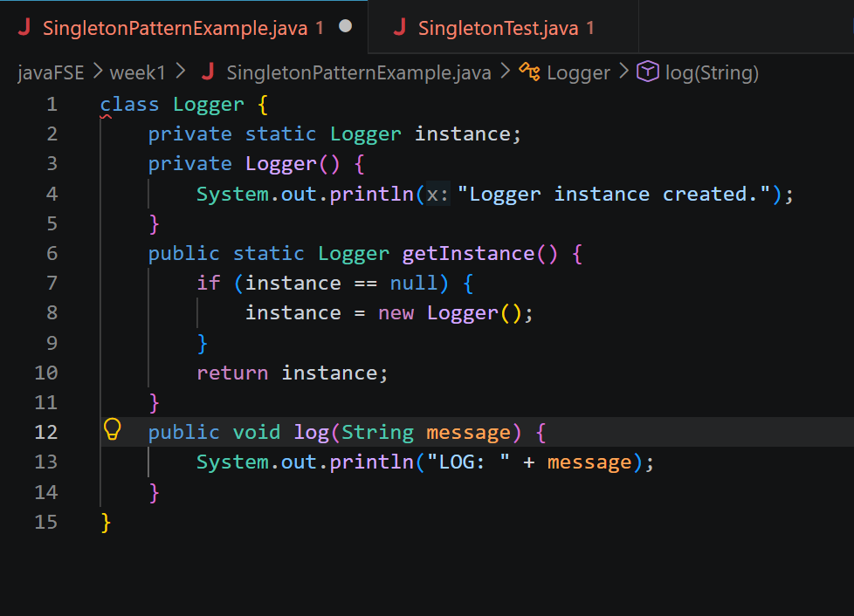
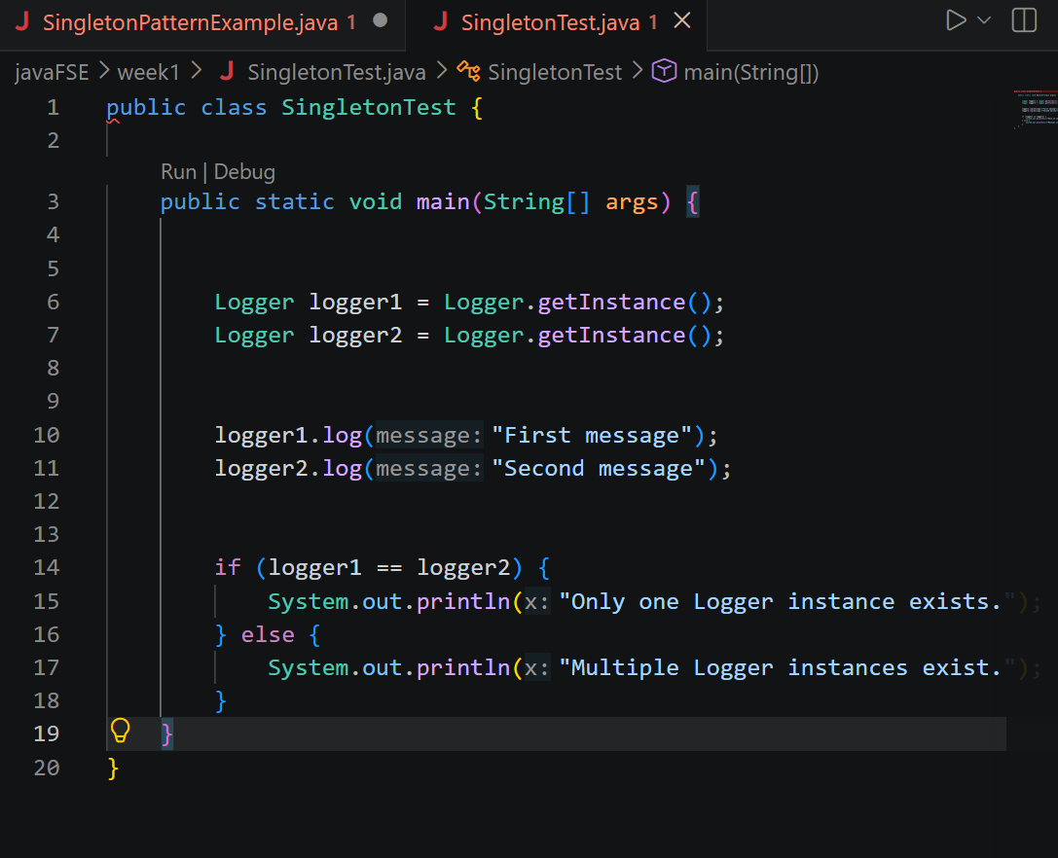
Output:
